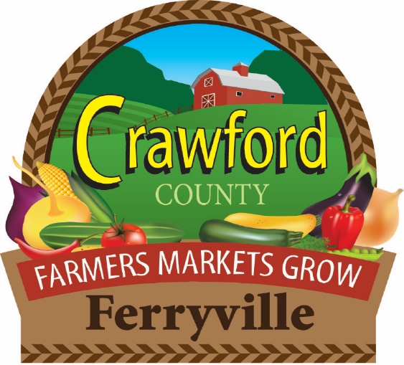
Ferryville Farmers Market
FALL FEST 2025 REGISTRATION FORM
September 20, 2025
PRINT:
Name____________________________________
Street Address_____________________________
City__________________ State_____ Zip______
Phone: ( )-____ - ____ Cell: ( )-____ - _____
EIN/Sellers Permit#/Last 4 SSN
Email:____________________________________
Products to be sold:_________________________
Fee: $20.00 Season Pass Vendor or $25 Weekly Vendor. Electrical Fee $3 (if used)
Checks payable to Ferryville Farmers Market. $35 charge for NSF checks
Attn: Janelle Anderson, 58714 Buck Creek Road, Ferryville, WI 54628
Cell: (715) 216-1411 Email – ferryvillefarmersmarket@gmail.com

